**Layers of service oriented architecture**

View, control, service, domain, persistence

**Domain driven design**

Separation of conecepts, the business logic objects are independend of the enterprise service objects

**Advantages of ddd**

Business logic is independent of thecnology changes (switch between thecnology is easy)

Business logic is easy to understand

**Declarative programming**

It says what to do but no how to do it

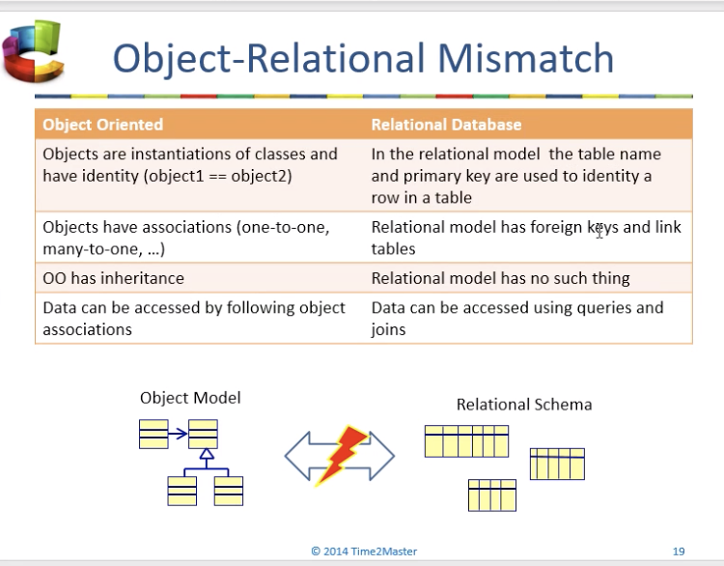

**Object relational mapping**

It lets the programmer focus on the object model

Supports ddd

Programmers work with objects

Changes can automatically be store in db

Advantege.- productivity, maintainabily, performance

**Jpa**

Java standard for ORM

**Ways to use hibernate**

Xml, annotations and jpa using anotattions

**Sample hibernate.cfg.xml**

<hibernate-configuration>

<session-factory>

<!-- MySQL DB running on localhost -->

<property name=*"connection.url"*>jdbc:mysql://localhost/cs544?serverTimezone=UTC</property>

<property name=*"connection.driver_class"*>com.mysql.cj.jdbc.Driver</property>

<property name=*"connection.username"*>cs544</property>

<property name=*"connection.password"*>201511</property>

<property name=*"dialect"*>org.hibernate.dialect.MySQL5Dialect</property>

<!-- Use the Hibernate built-in pool for tests. -->

<property name=*"connection.pool_size"*>1</property>

<!-- Show all SQL DML executed by Hibernate -->

<property name=*"show_sql"*>true</property>

<property name=*"use_sql_comments"*>true</property>

<property name=*"hibernate.format_sql"*>true</property>

<!-- Always drop and recreate the database schema on startup -->

<property name=*"hbm2ddl.auto"*>create</property>

<!-- Mapping files -->

<mapping class=*"edu.mum.cs.cs544.lab6.Payment"* />/>

</session-factory>

</hibernate-configuration>

**Primary key**

Unique, constant, required

Natural key (has meaning in the business) surrogate key (has no meaning, best practice)

**Data types**

@column name="column", lenghth=200, nulleable=false

@temporal.- to specify how date should be persisted

@Lob.- large values

@trasient.- property no persisted

**reflection**

you can call private method and access private fields outside the class

**Property or field access**

Field access get and sets the values directly from the field

Property get and sets from gets and sets

**Life cycle entity**

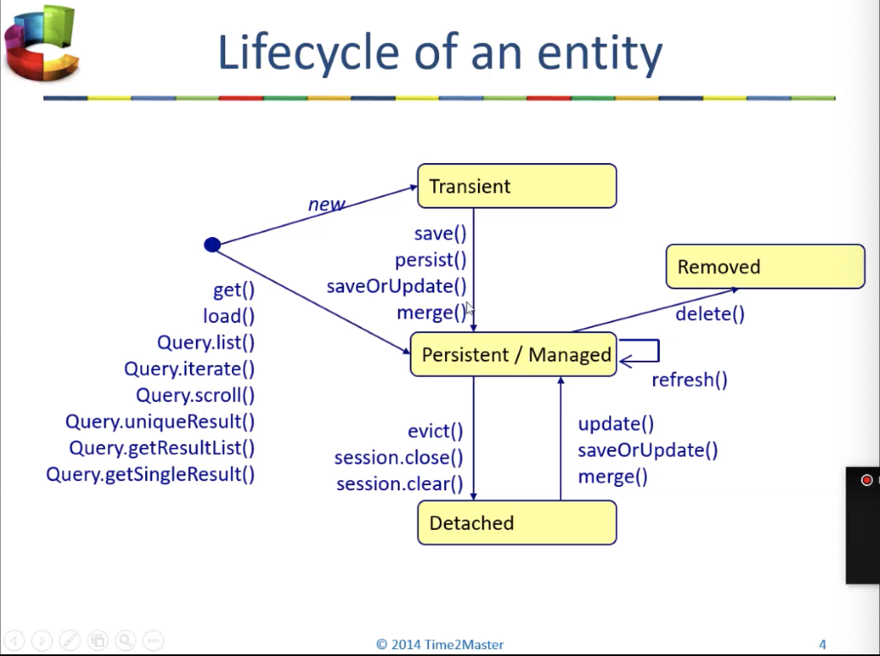

It is in *persistence context* sits between client code and data store

Managed.- is the state where every change made on it will be tracked and propagated to the database automatically. has database identity

Detached.- is a ordinary POJO, it is not in session. It has an id but any change do not persists in the db. Has database identity but it nos managed by persistence context

Trasient.- is simply an *entity* object that has no database identity and is not managed by any *Session*.

Removed.- if *Session.delete(entity)* has been called, and the *Session* has marked the entity for deletion

**Dirty checking**

hibernate automatically detects whether an object is modified (or) not and need to be updated

**Merge**

replace the reference. It returns a copy of the database object

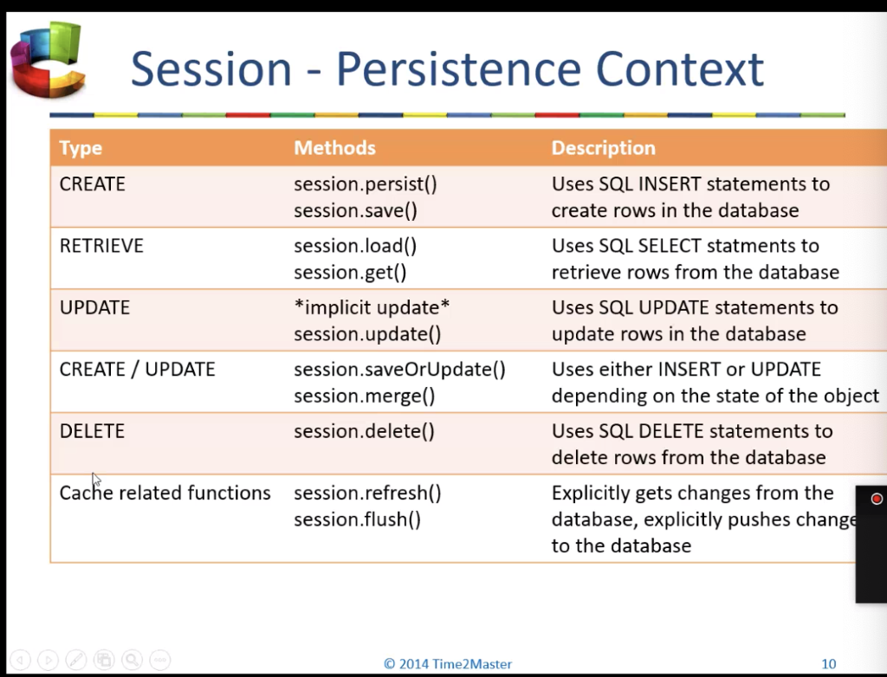

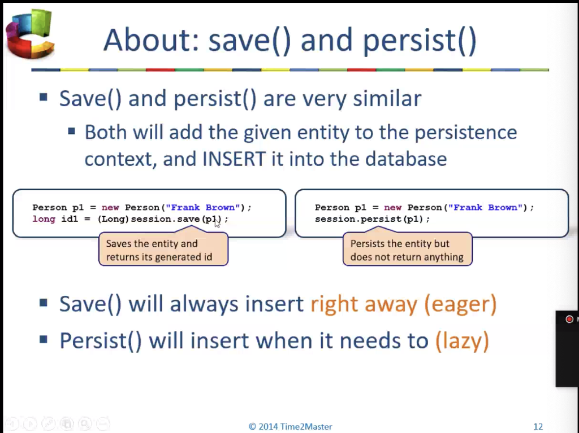

Save return the id, persist return void

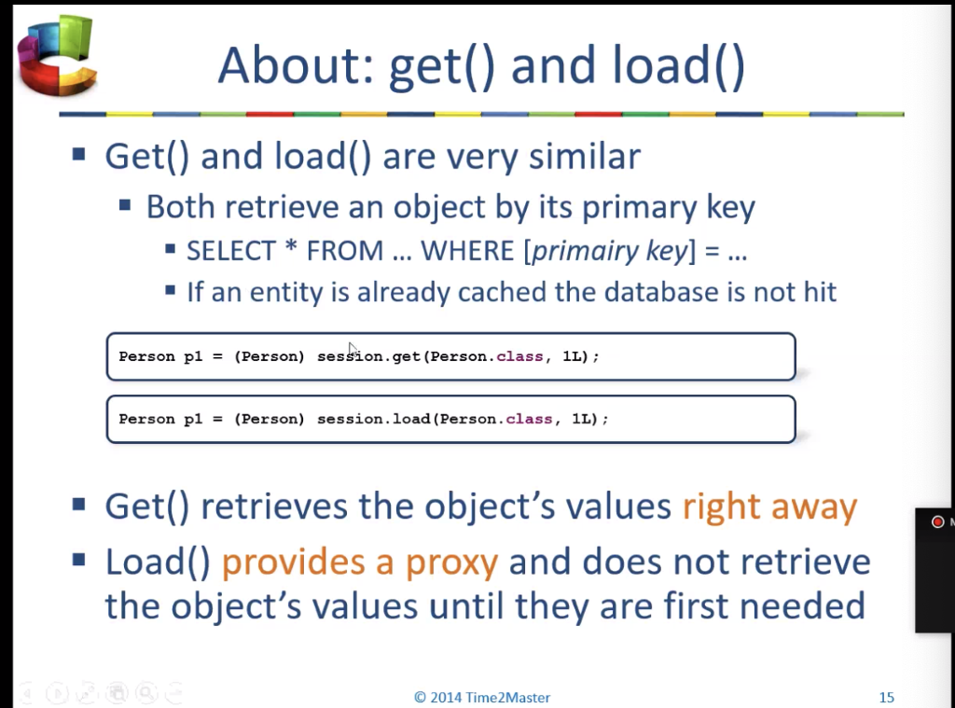

Load return an empty shell (lazy)

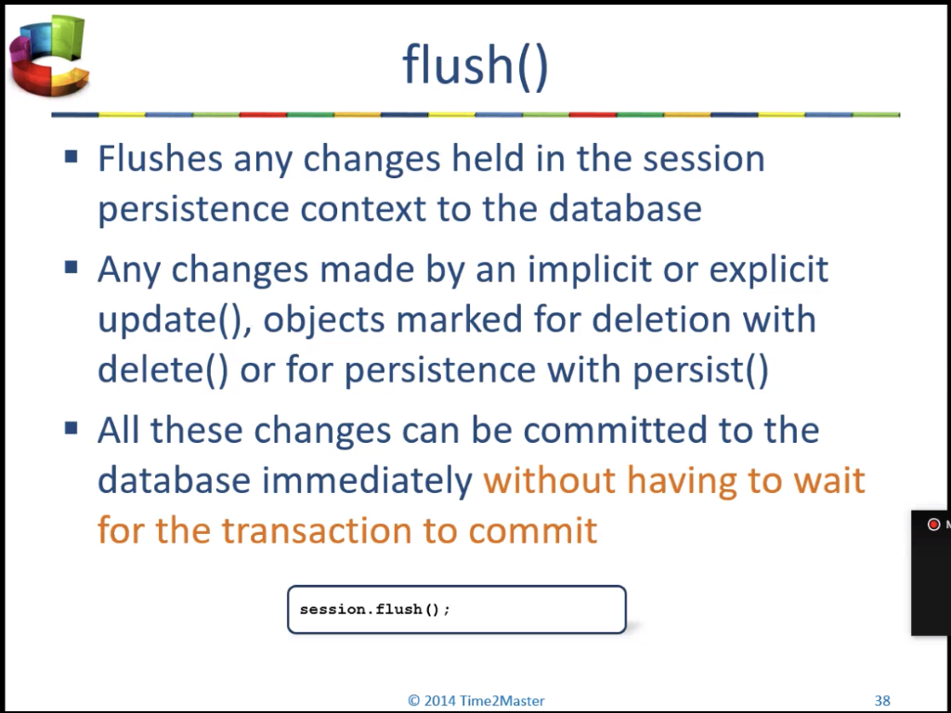

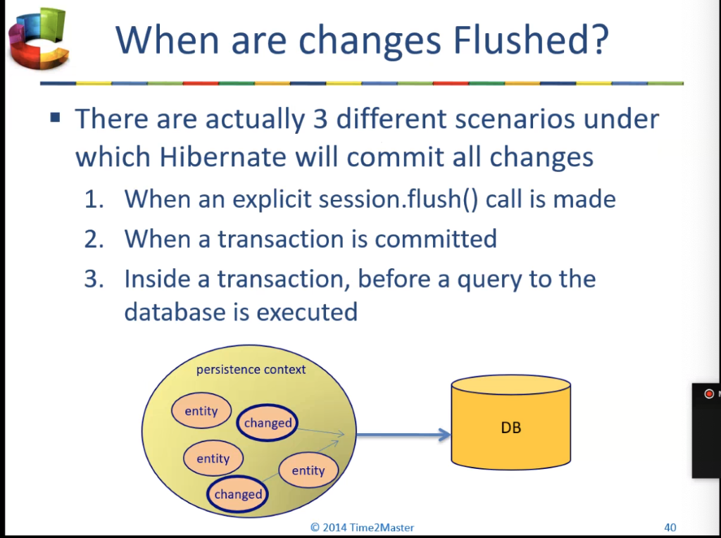

**Many to one**

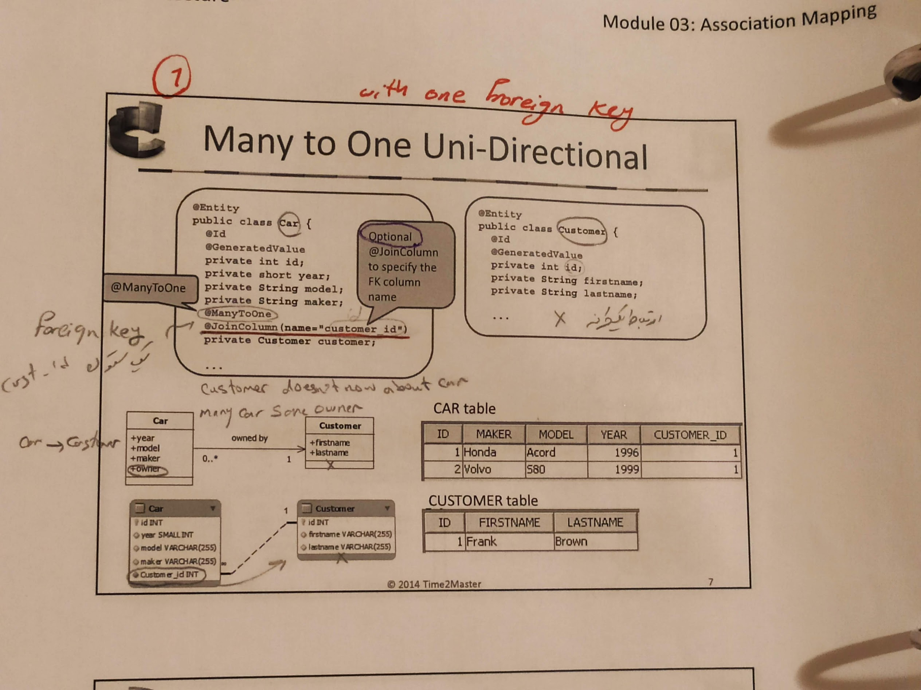

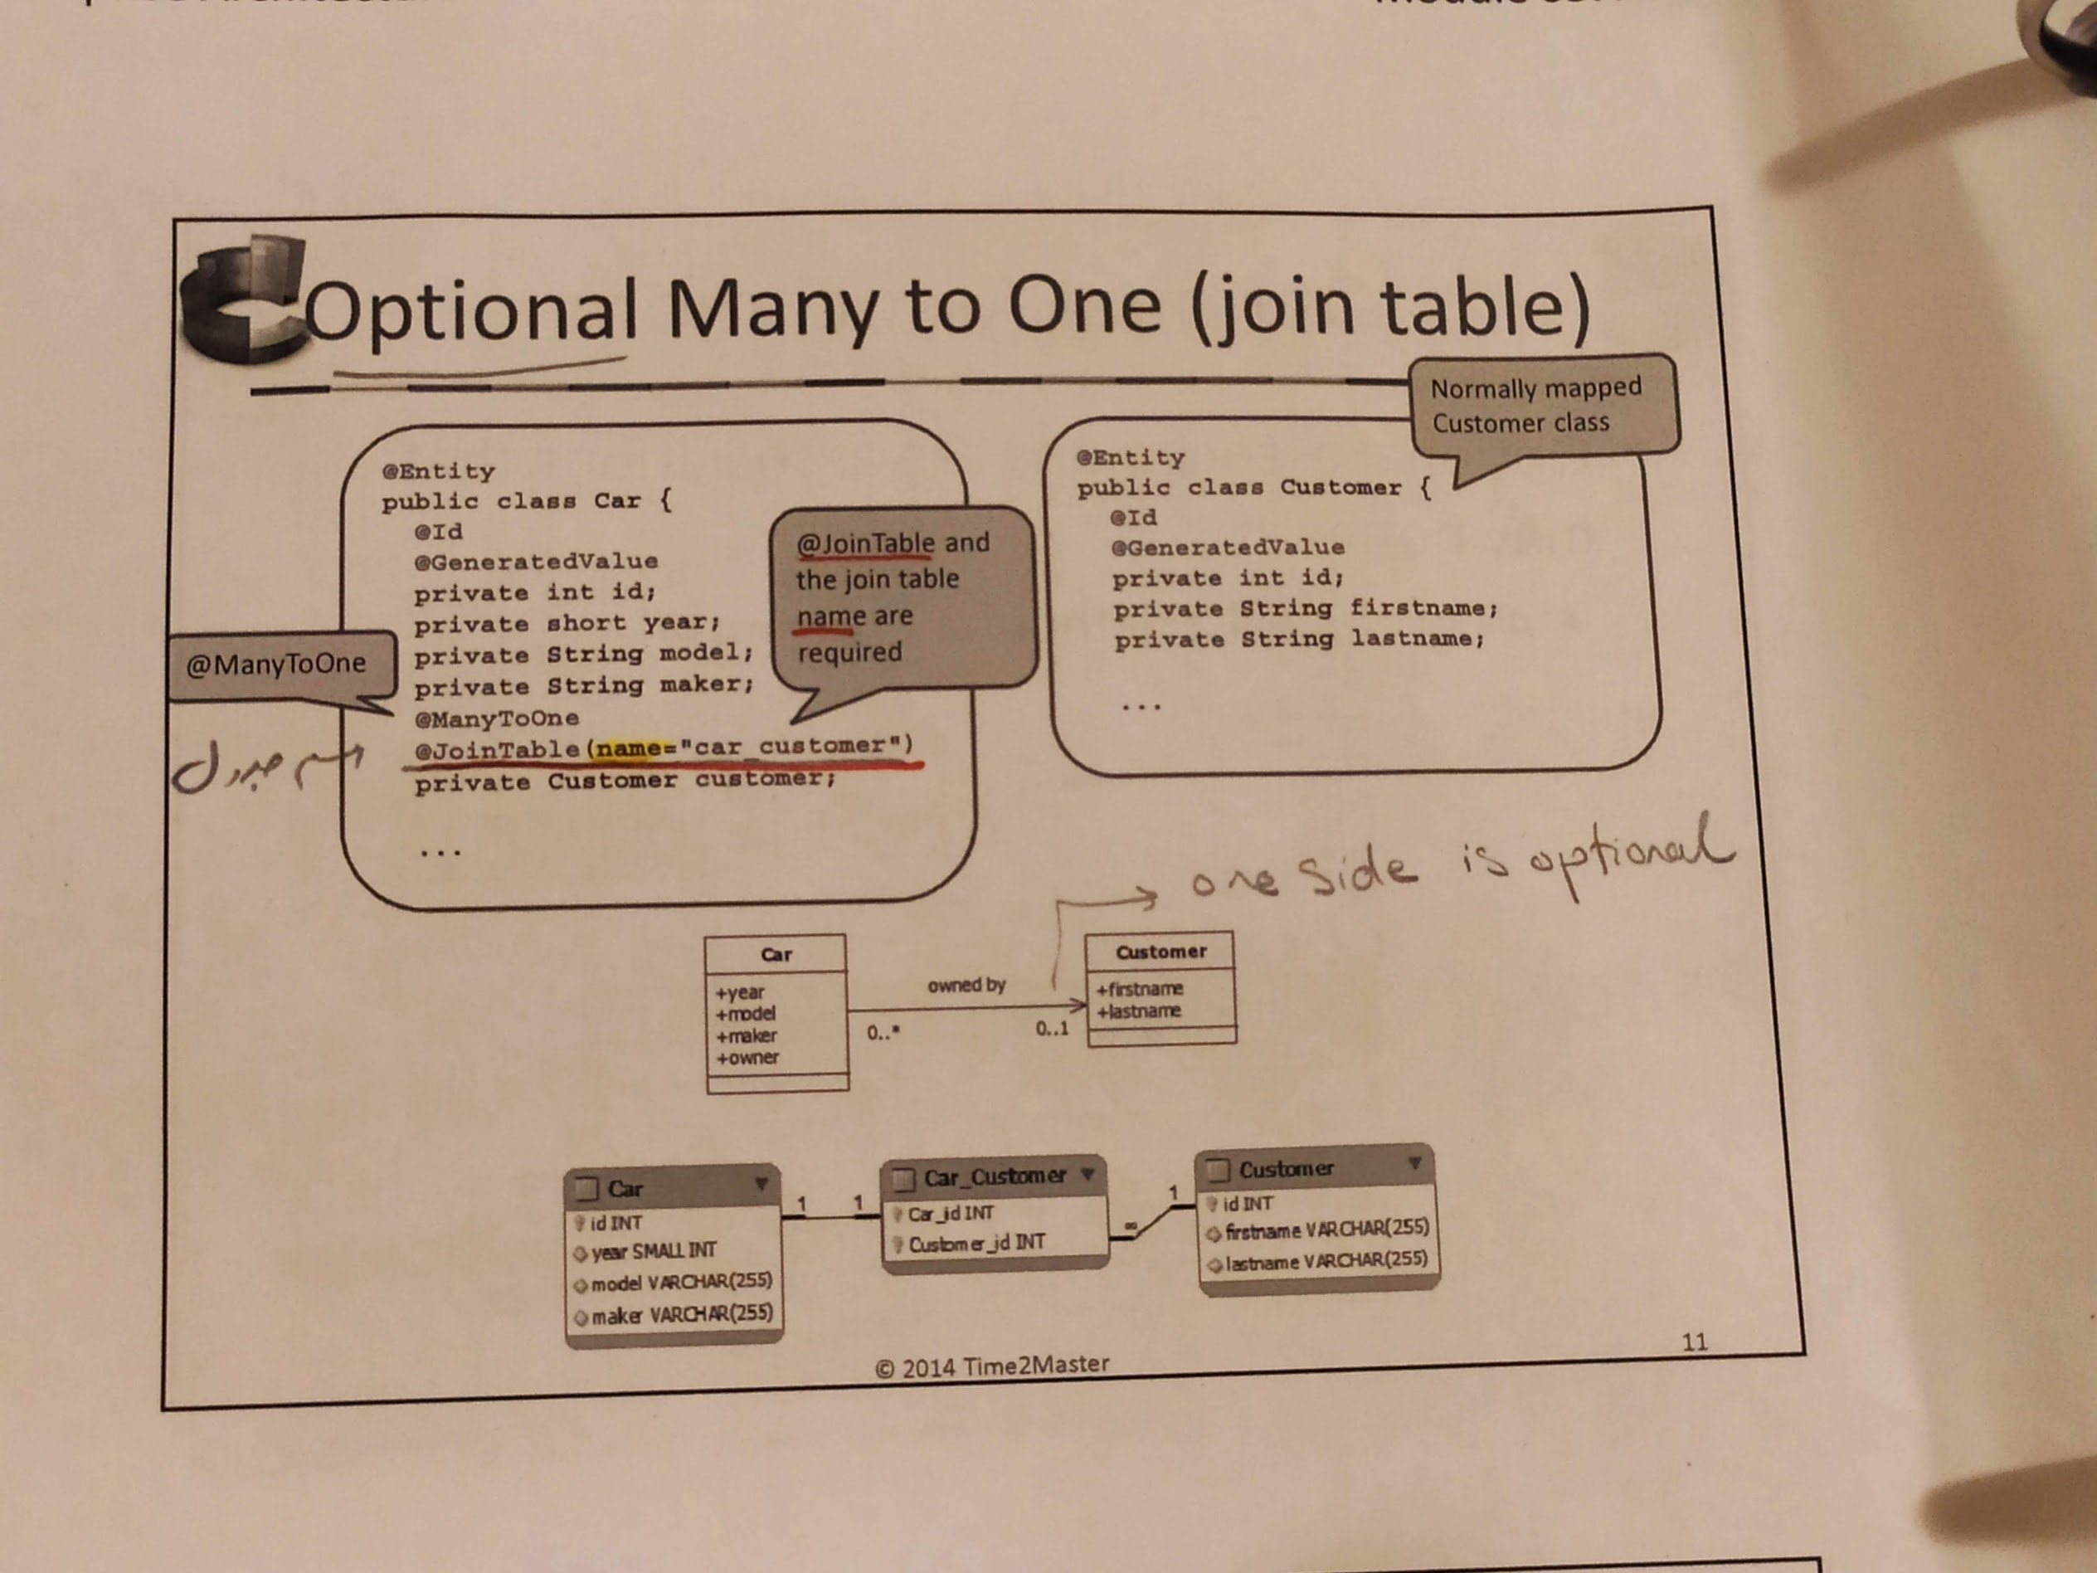

**One to many**

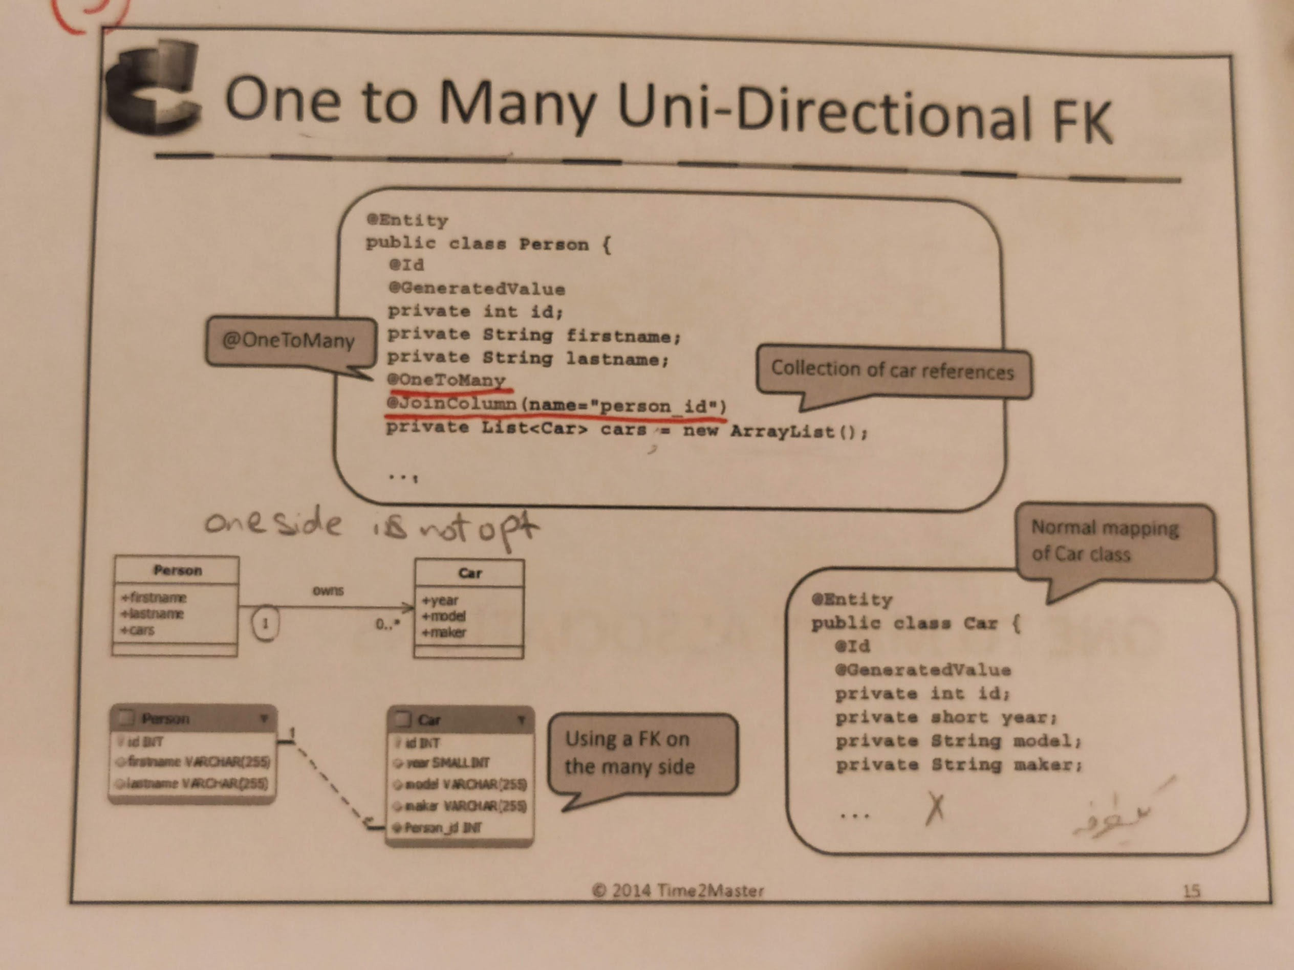

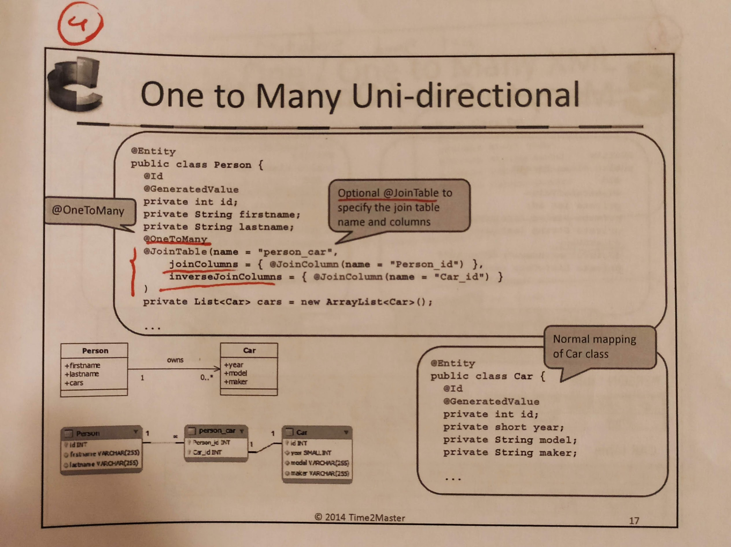

One to many/ many to one

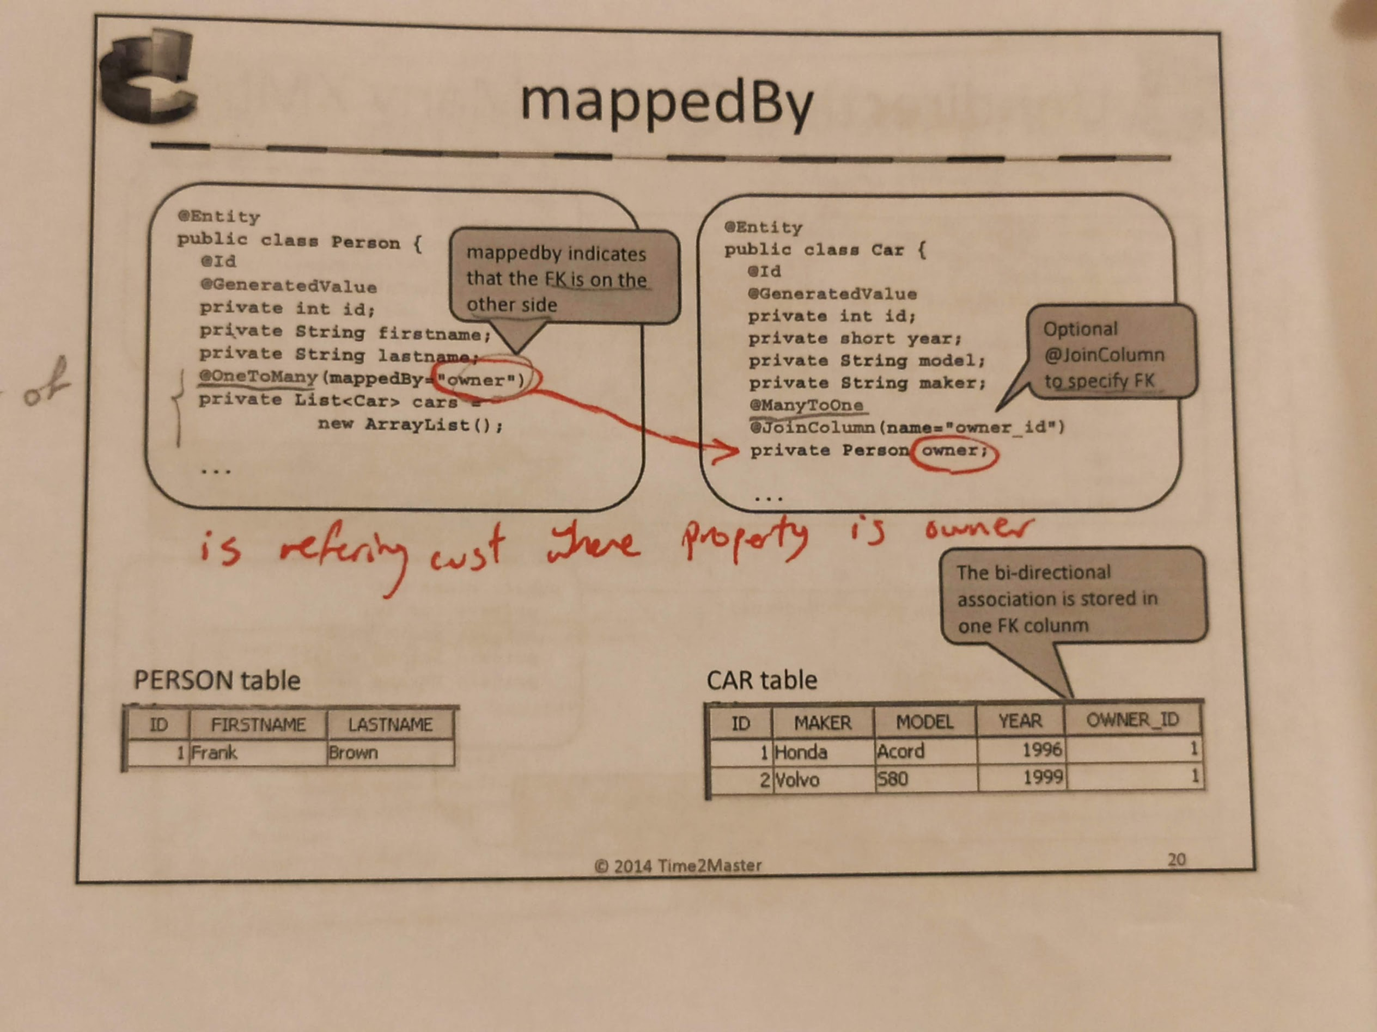

One to one

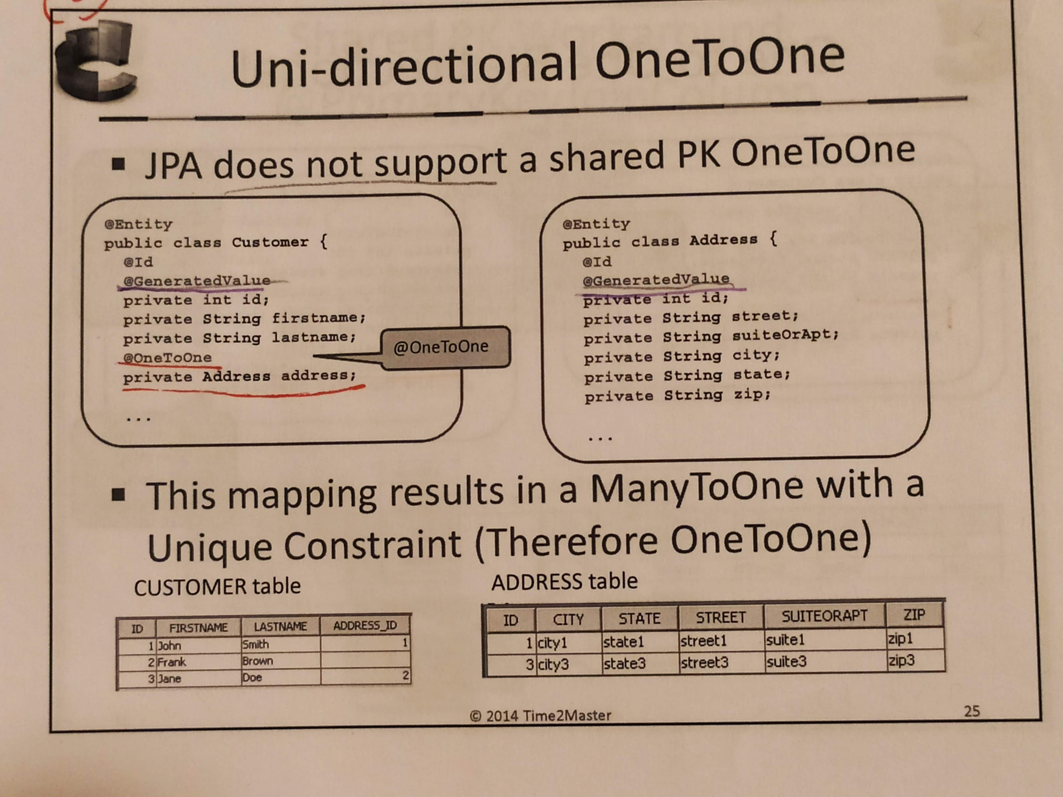

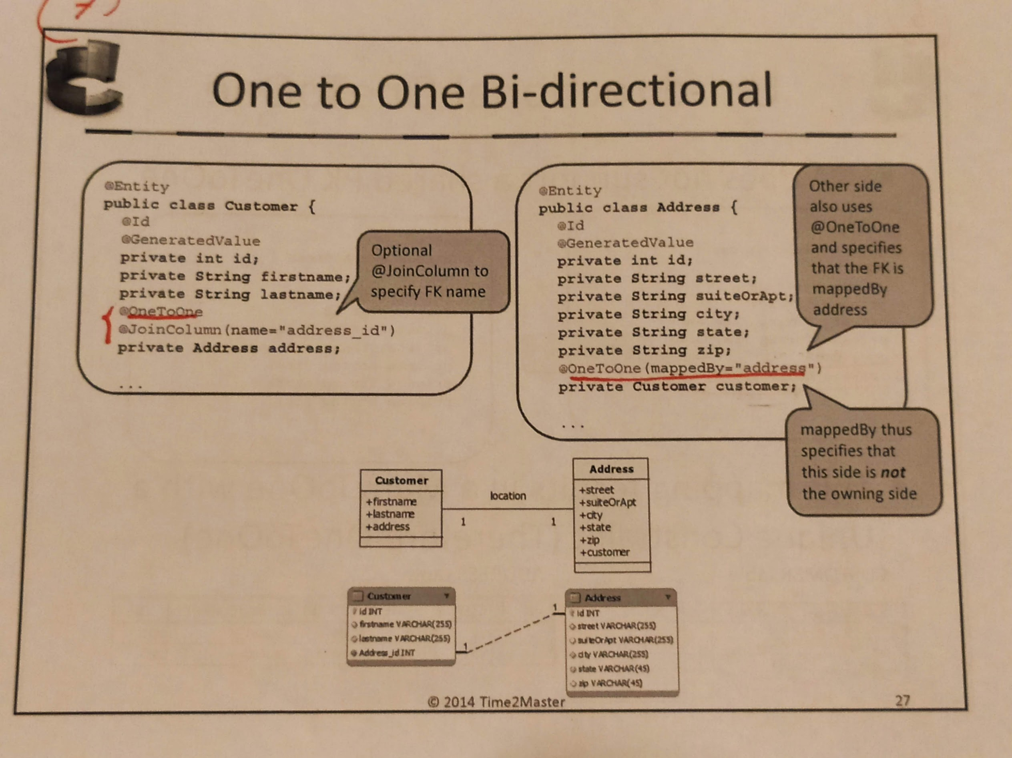

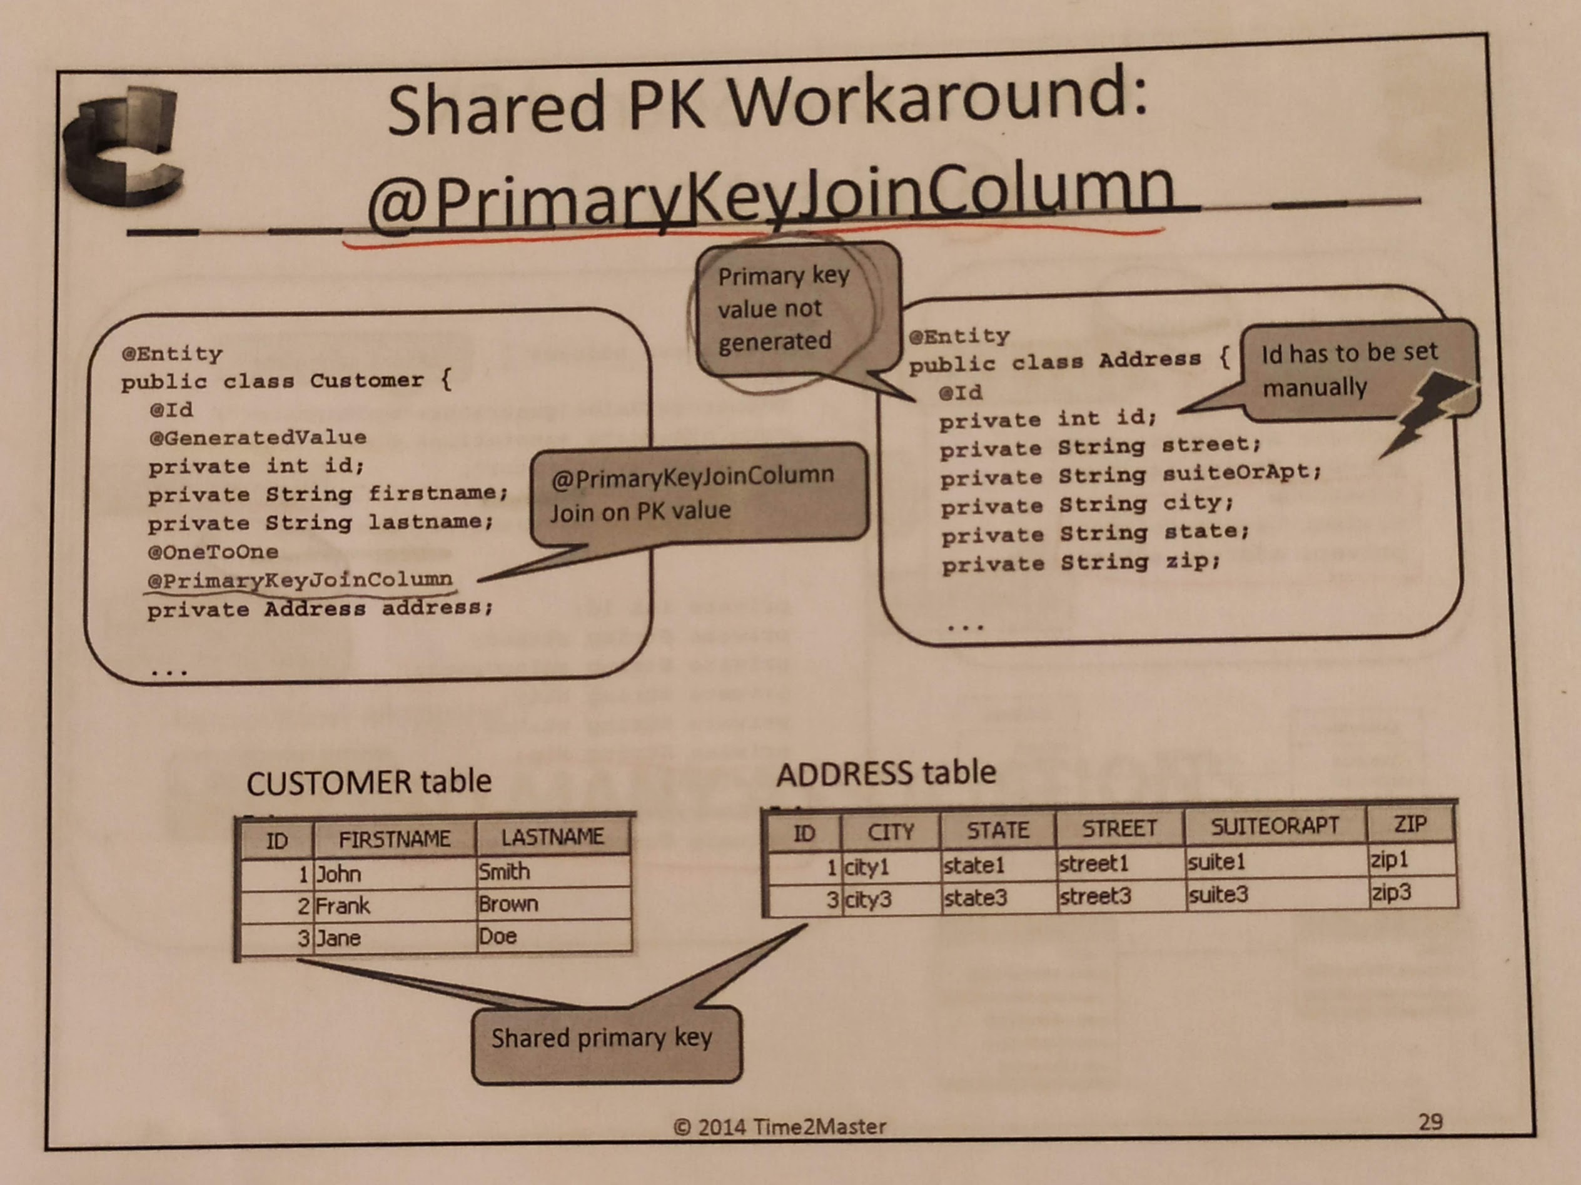

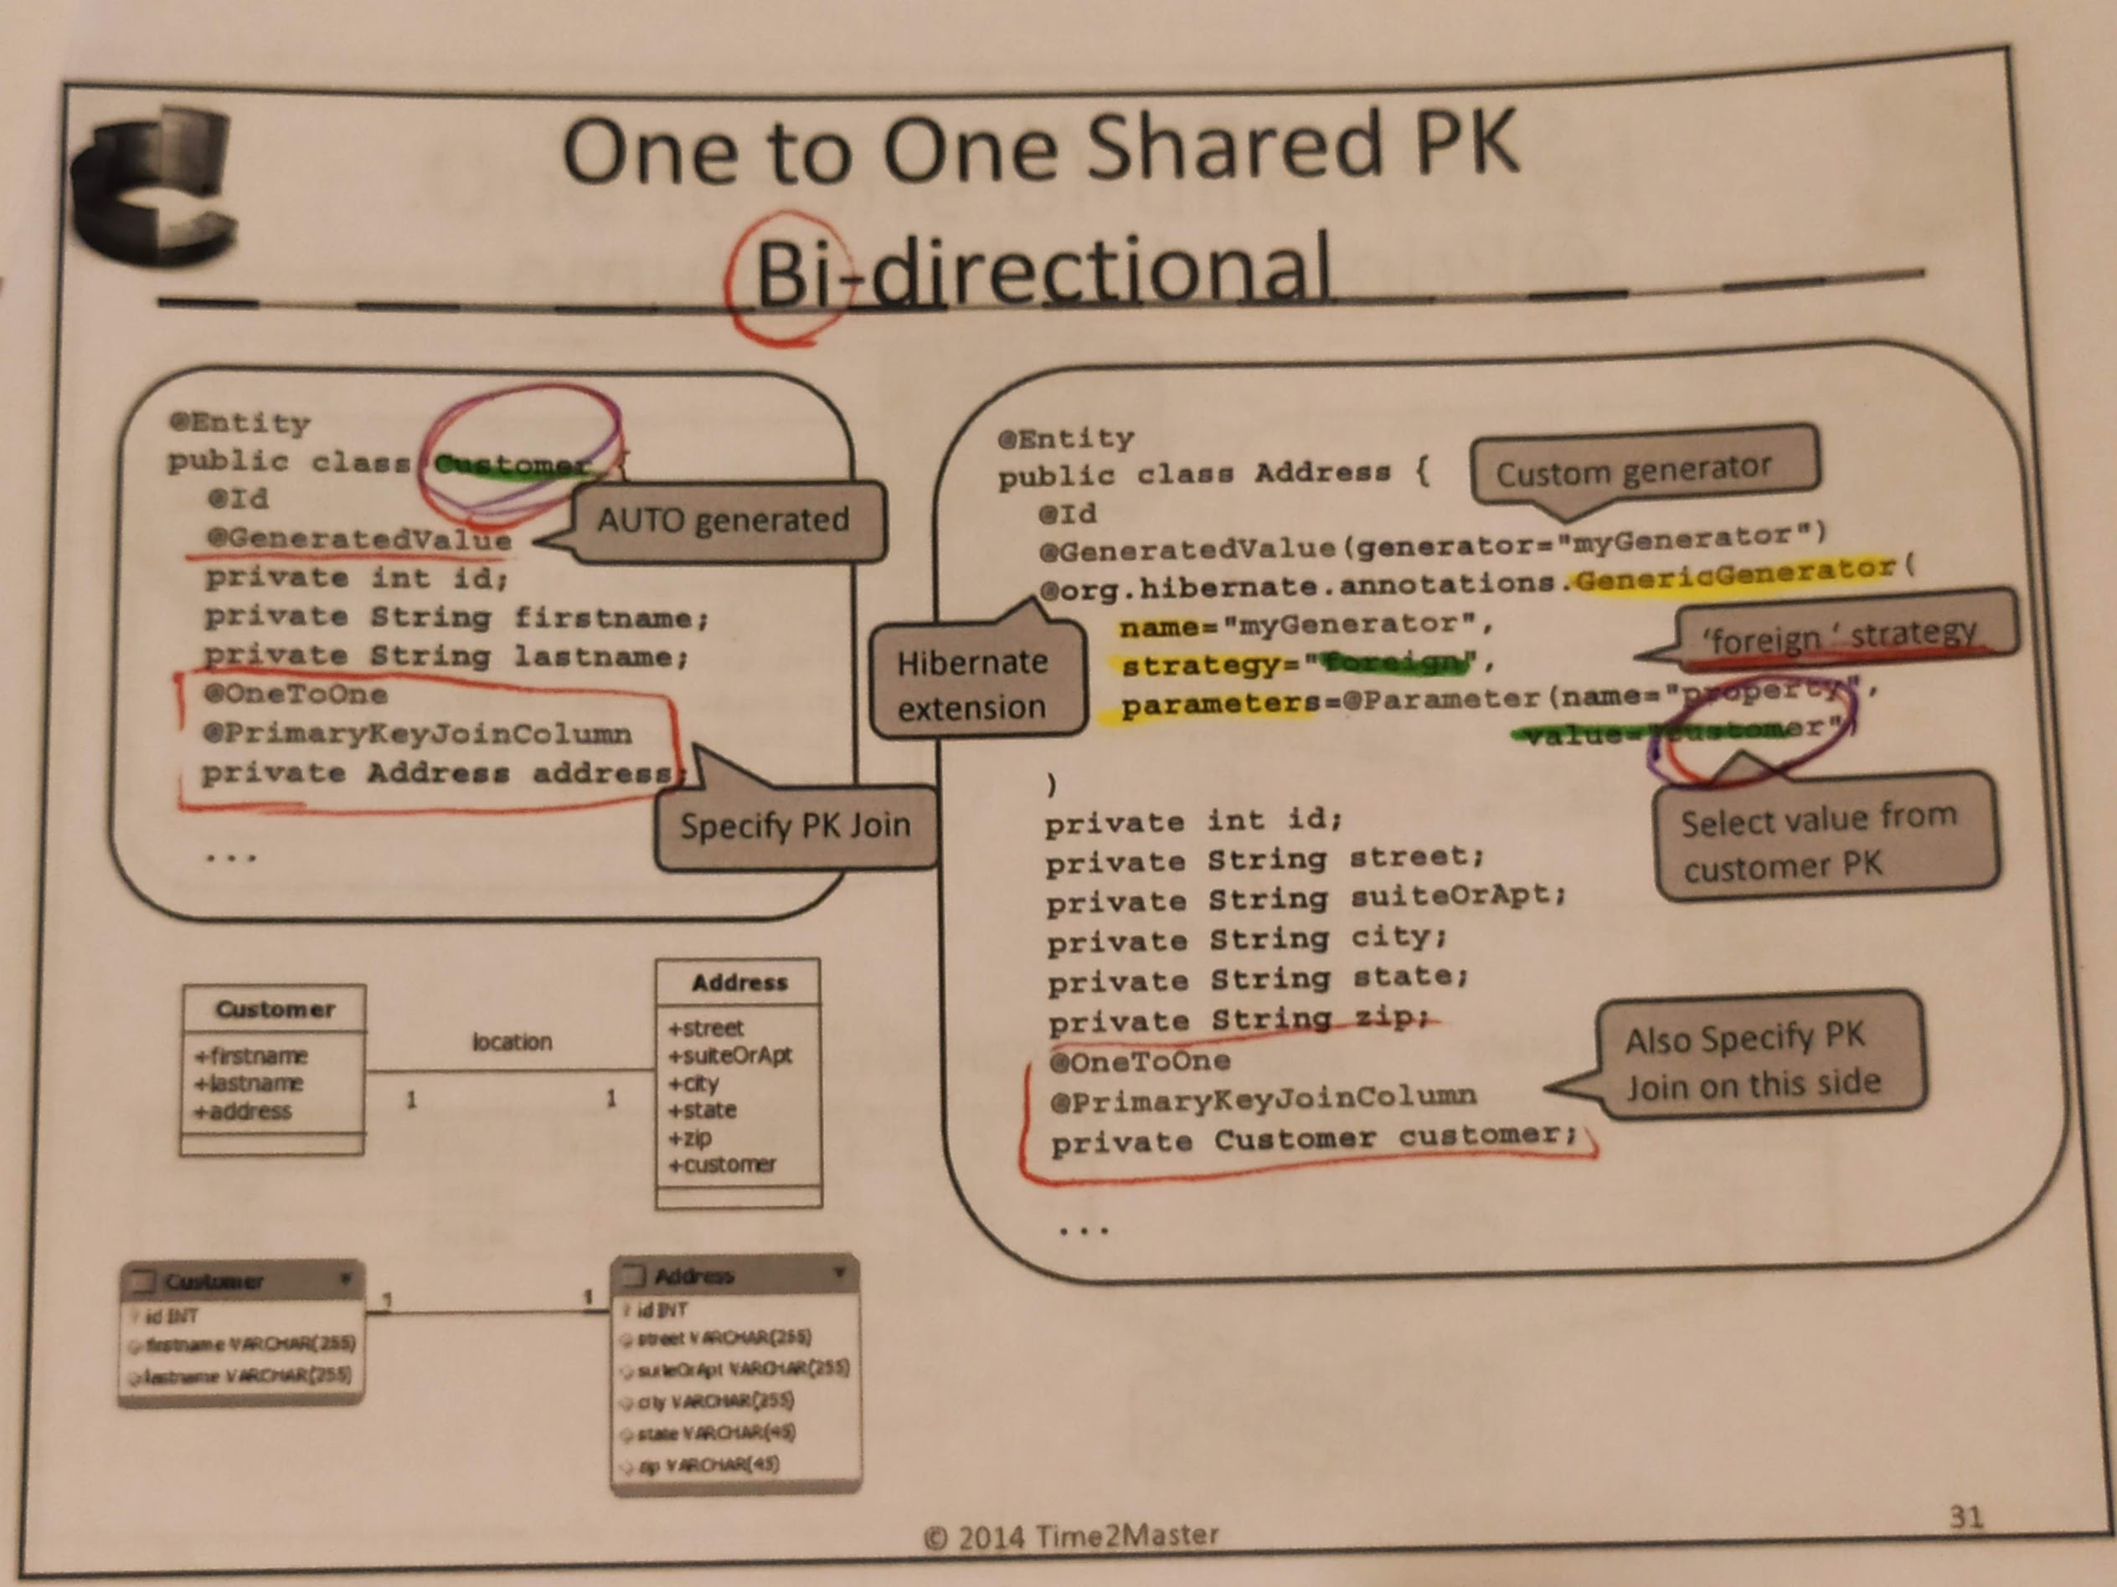

Many to many

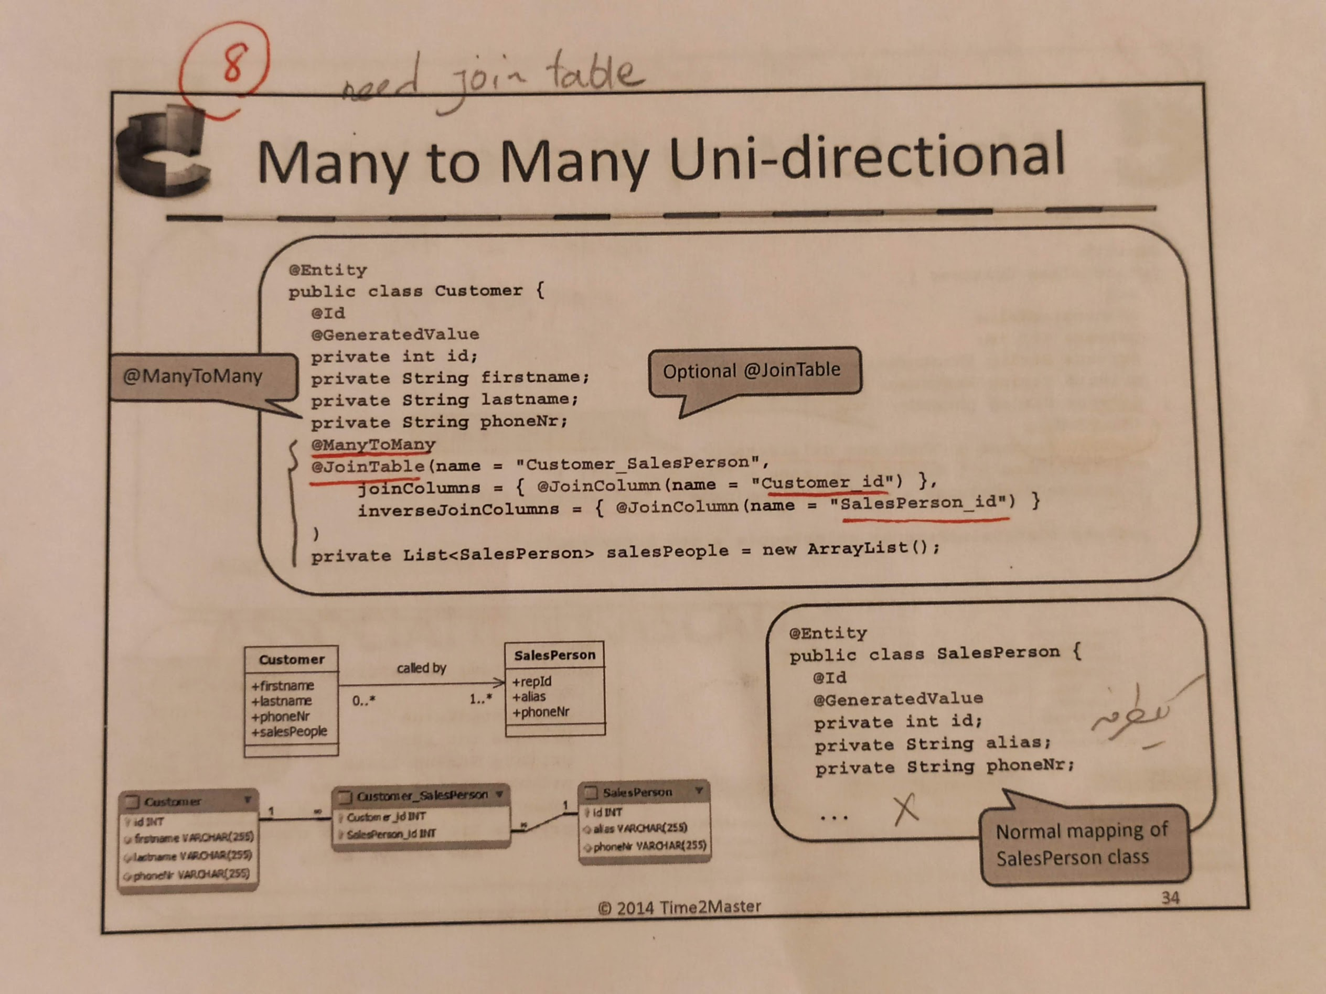

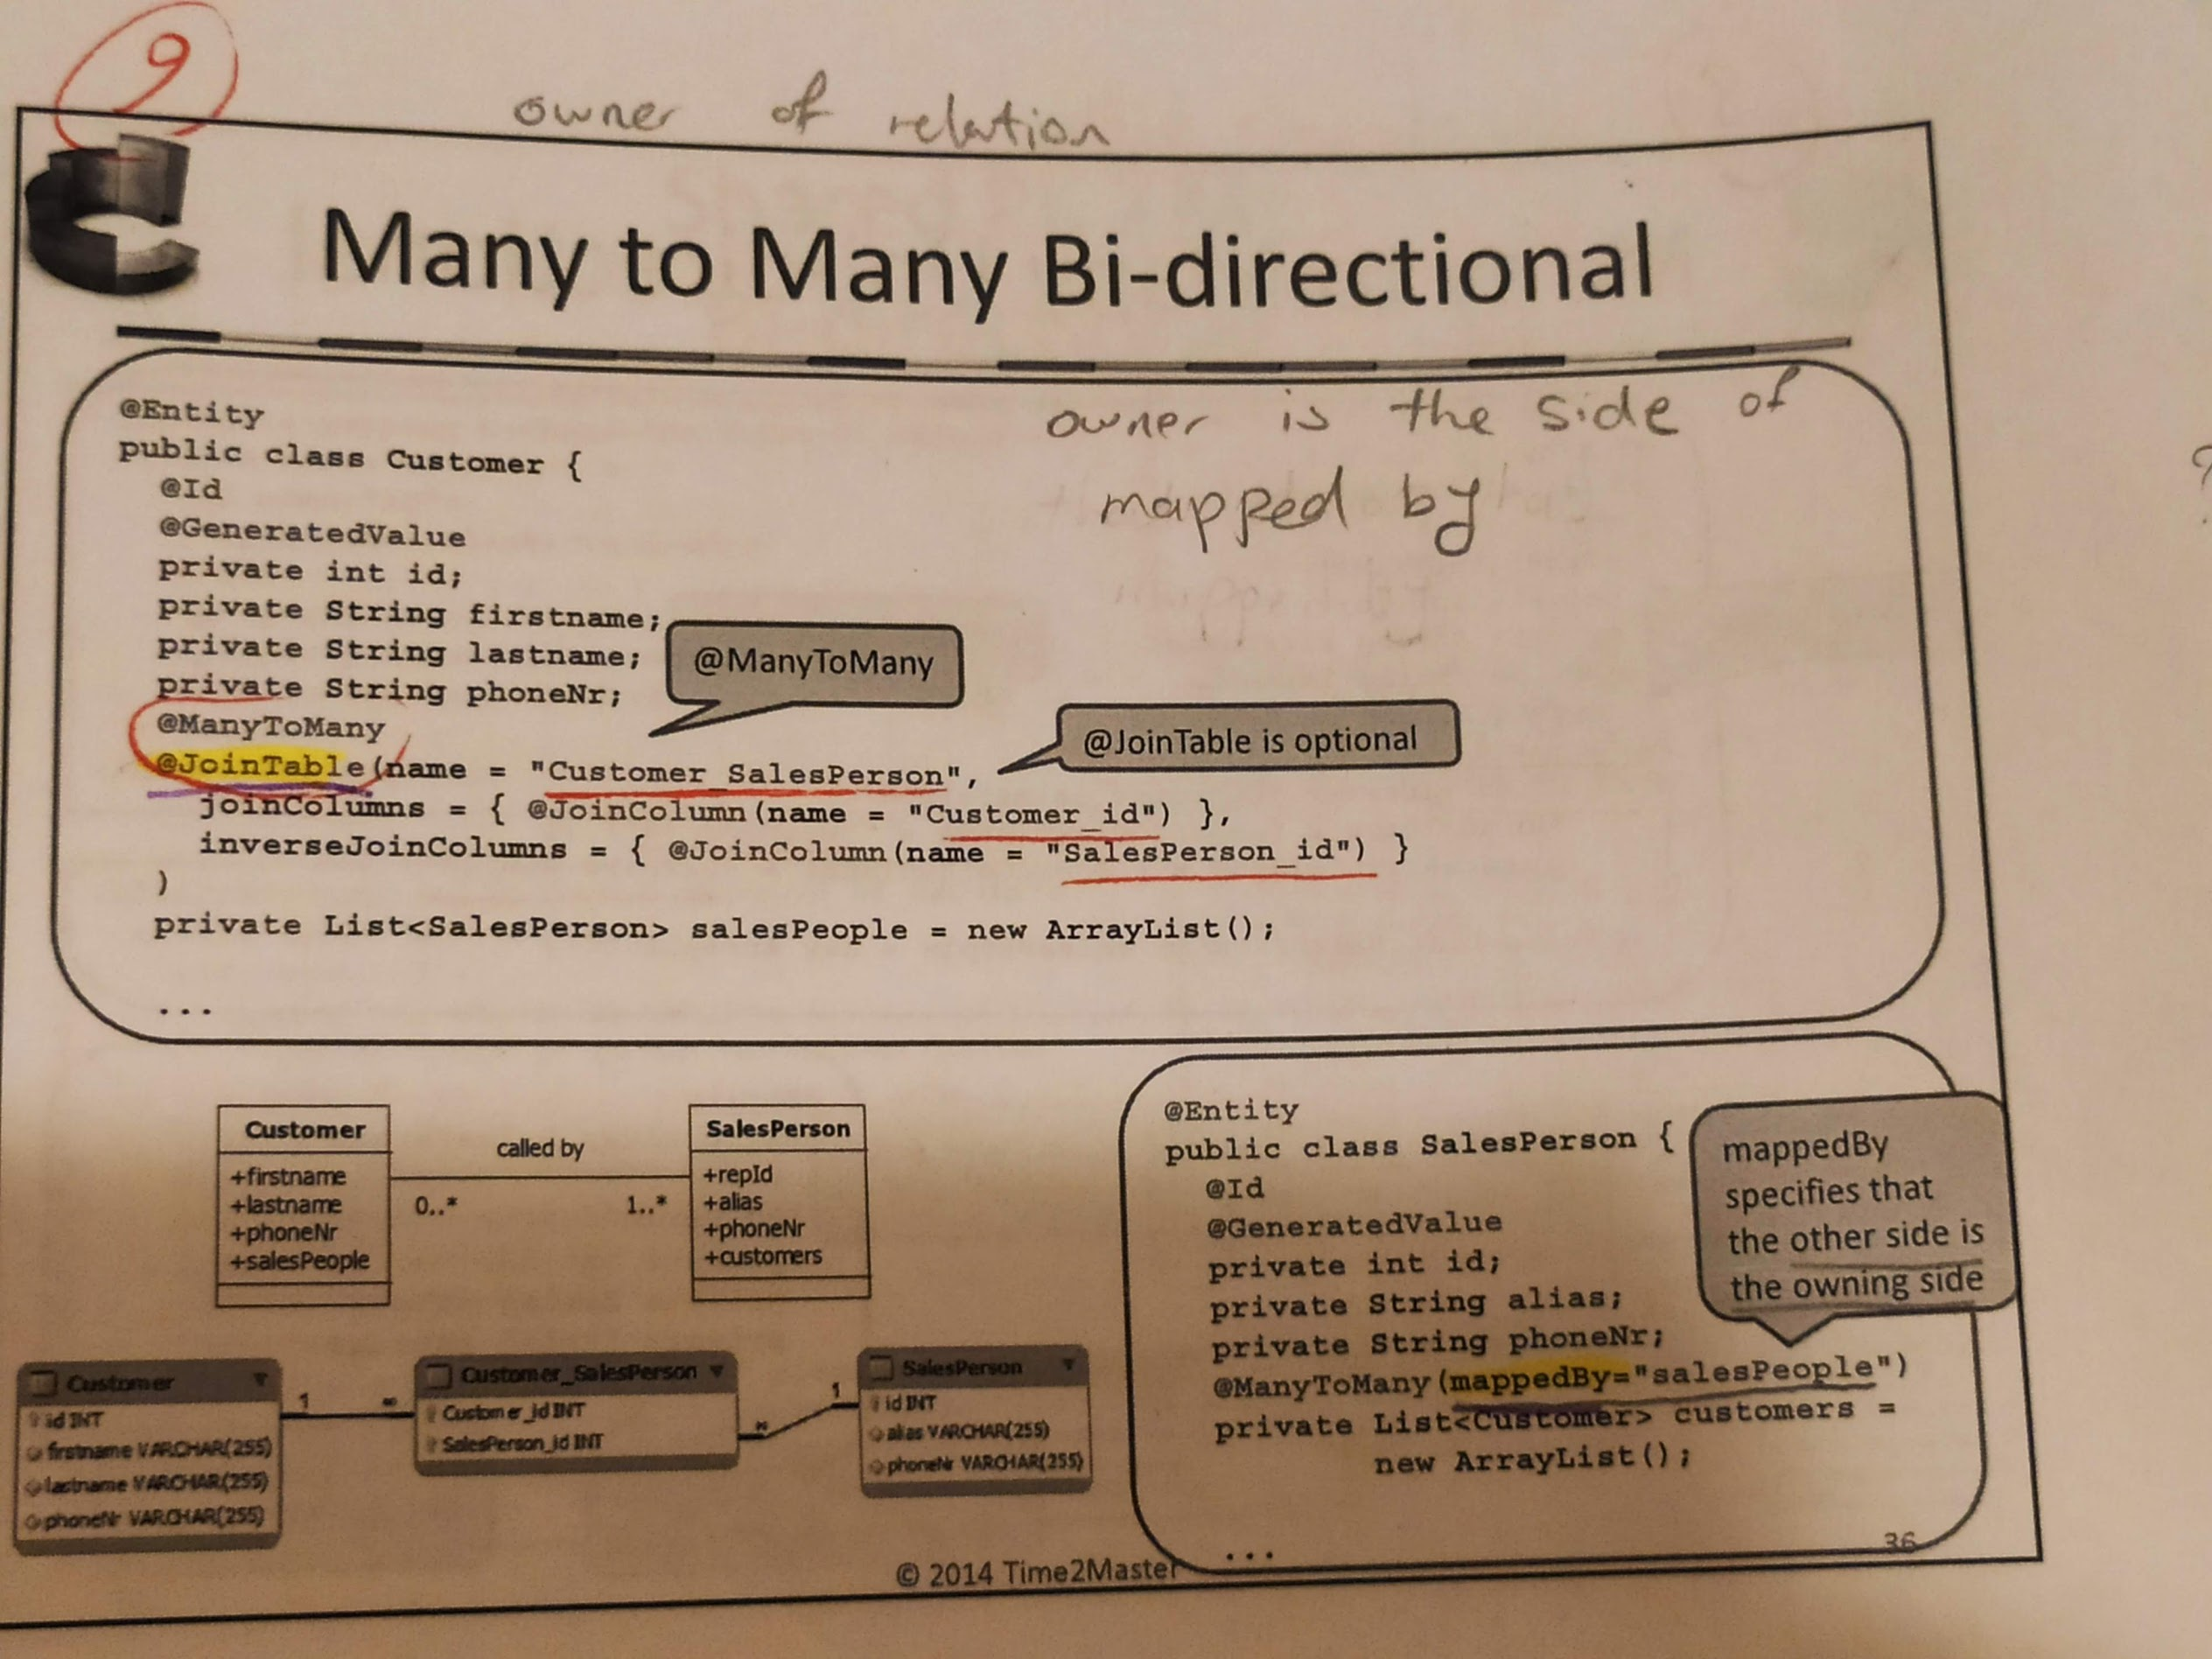

**Collection mapping**

Bags.- no order and duplicates

List.- order duplicates

Set.- no order no duplicates, you must overwrite equeals and hashcode

Map.- unique key and no order

**Complex mapping**

**Secondary tables**

Secondary tables can be used anywhere to move properties into separate table(s)

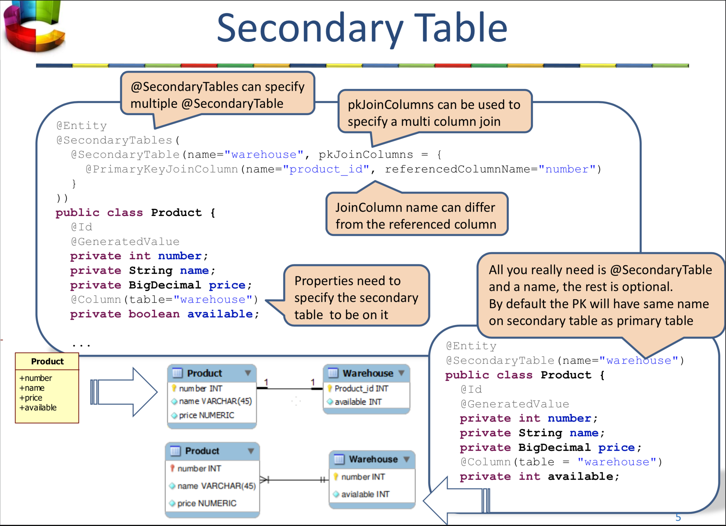

**Embedded classes**

**Combine multiple classes in single table**

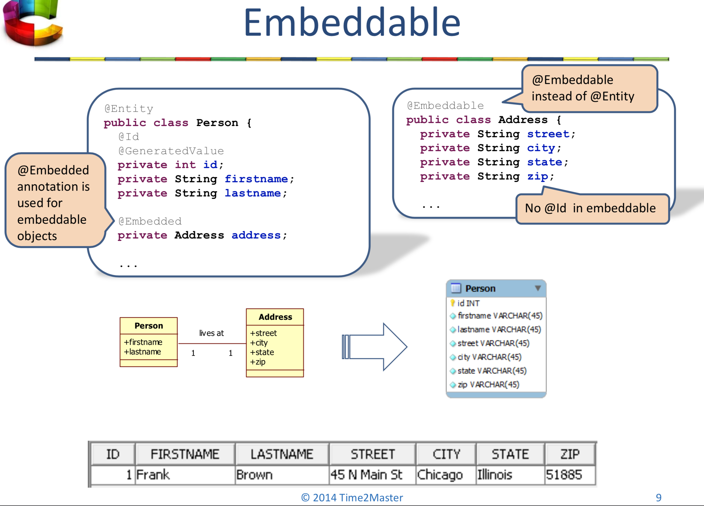

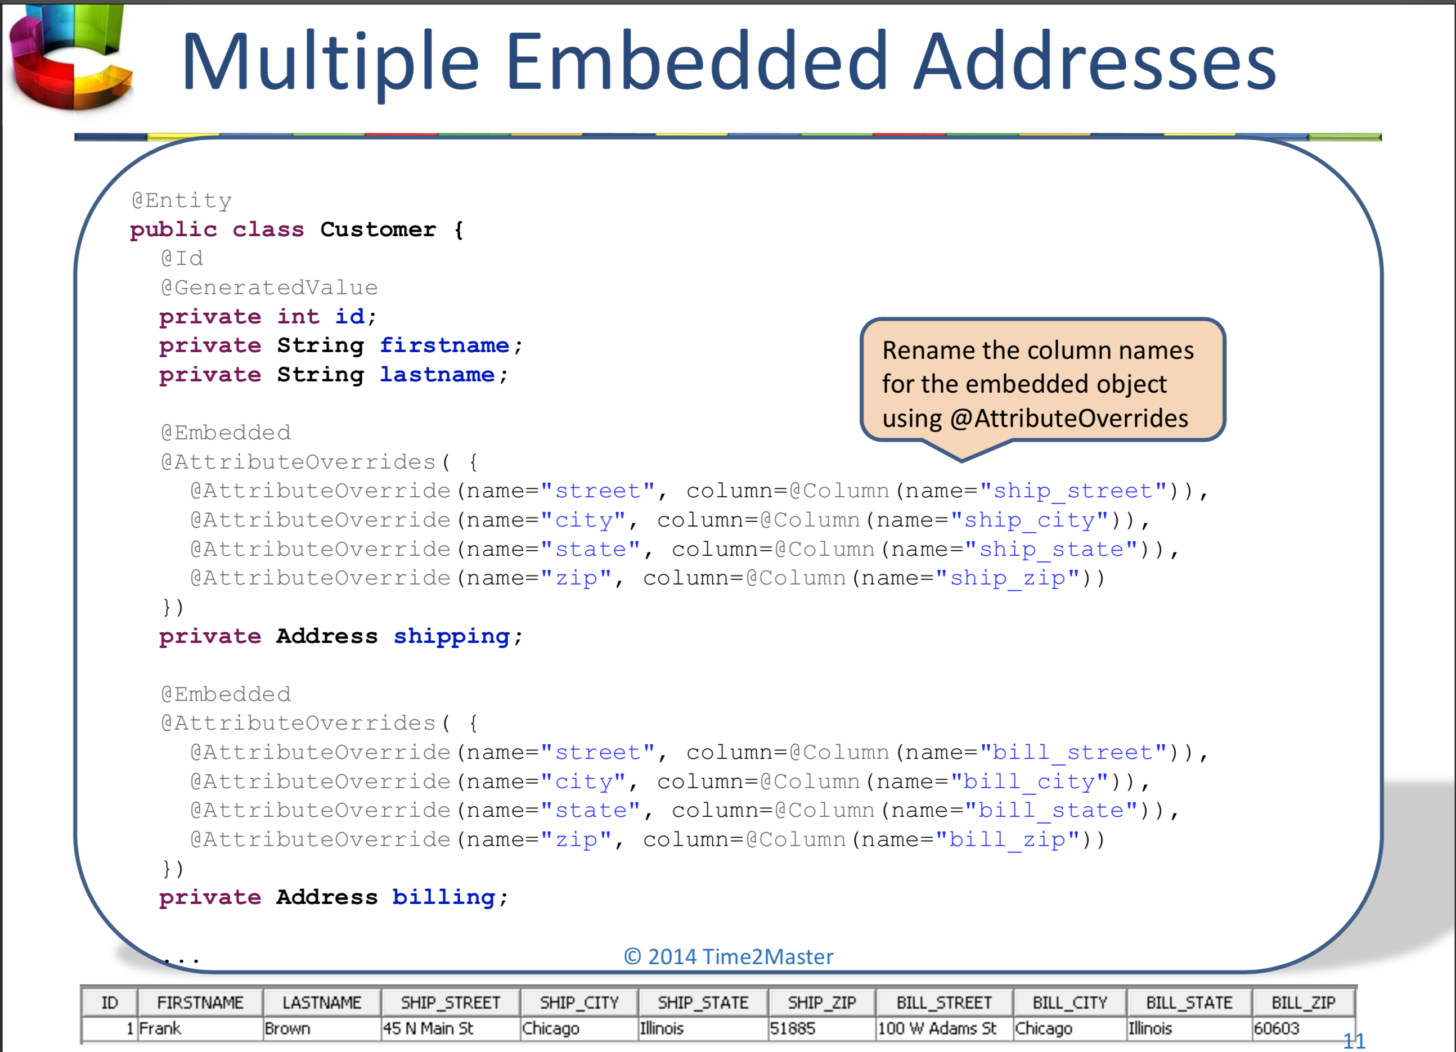

**Composite keys**

Composite Keys are multi-column Primary Keys

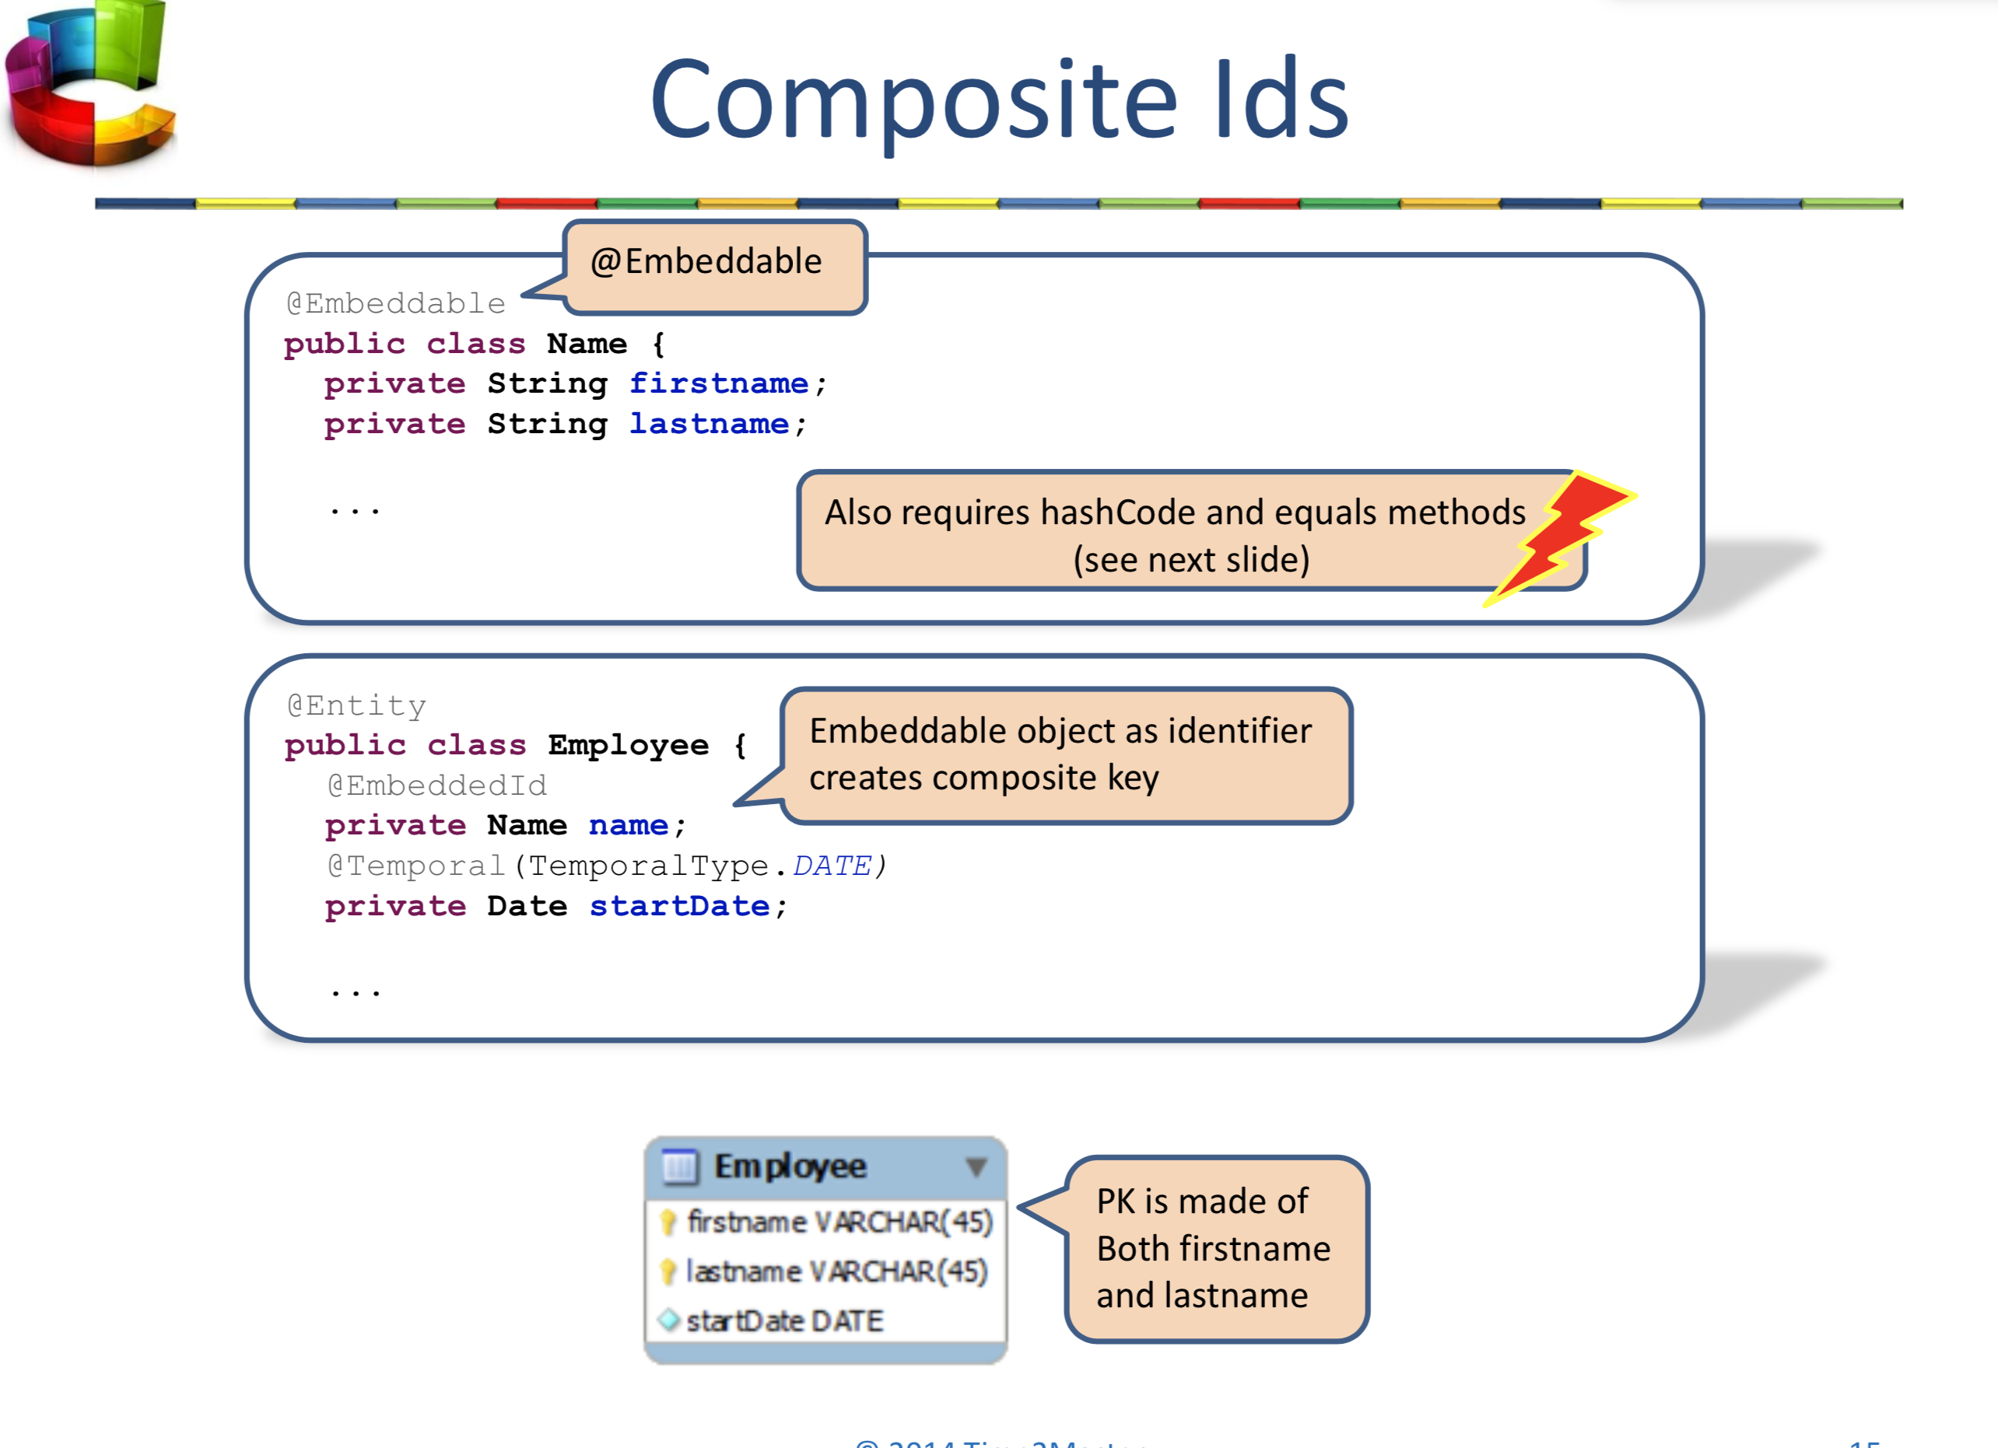

**HQL**

HQLs syntax is relatively similar to SQL, but is object oriented instead of relational

**Named queries**

Named HQL queries can be stored inside mapping data

